**Design of a Compact Planar Monopole Patch Antenna For Ultra Wide Band Applications**

Karapakula Balaji Deekshitha

Department of E.C.E.

Chadalawada Ramanamma Engineering College (Autonomous),Tirupati,Andhra Pradesh,India

**Email id:** [deekshithakb2000@gmail.com](mailto:deekshithakb2000@gmail.com)

***Abstract—*** This paper presents a design of a compact planar monopole antenna for wireless communication. The dimensions of the proposed antenna are 20mm*25mm*1.6mm.The substrate named FR-4 epoxy with loss tangent of 0.025 and dielectric constant of 4.4 on which the antenna structure is etched and is fed by a microstrip line. The presence of the semicircular slots in the ground plane assures a broad impedance bandwidth. The simulated results of the proposed antenna indicates impedance bandwidth of 3.58 GHz to 18.24 GHz with a peak gain of 6.96 dB and the radiation efficiency of 83% which are achieved in the operating frequency range of antenna. This antenna can be used for the UWB applications which includes WiMax band at 3.5/5.5GHz, X-band of 8-12 GHz, mainly used in satellite and wireless applications.

***Keywords***— compact, efficiency, gain, impedance bandwidth, semicircular slot.

I. INTRODUCTION

Due to development in the field of wireless technologies, we need the antennas which are compact in size along with high bandwidth and efficiency. So there is a large demand for broadband antennas especially for planar antennas. As these can be operated over larger frequencies and are suitable for various applications by introducing different shaped slots such as L-shaped, triangular, semicircular and circular ring. By implementing a curved slot in a proper manner to patch will increases the bandwidth of the antenna.These antennas low profile, light weight, ease of fabrication and compatibility in printed circuits.

II. EXISTING METHOD

A compact UWB planar antenna with corrugated ladder ground plane is shown. This antenna has dimensions of 25mm*20mm*1.8mm. The existing method is fabricated on FR-4 substrate. The lower order resonances are created due to the introduction of corrugated ladder shaped ground plane whereas

the circular patch with a circular slot matches impedance in the operating frequency band. The geometrical configuration with length is denoted as ‘b’ and breadth is denoted by ‘a’. The length of the microstrip line is denoted by ‘j’ and width as ‘w’. The thickness of the substrate is denoted ‘h’. The upper section of antenna contains a circular slot on the patch whereas the lower part of antenna consists of a corrugated ladder ground plane.

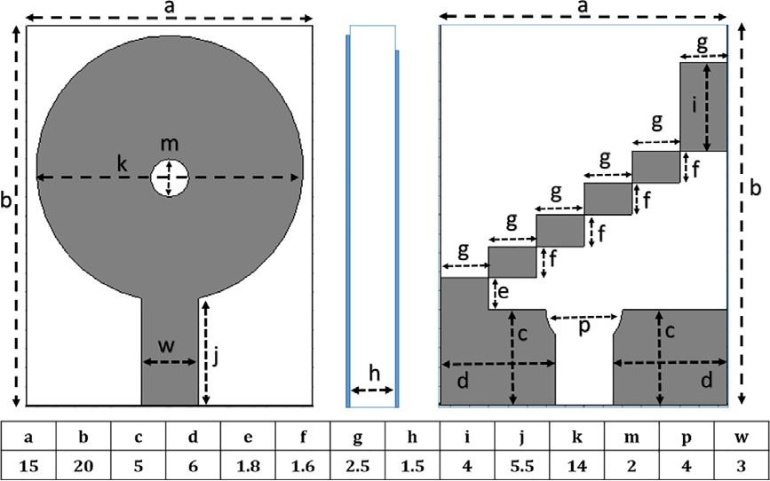

**Fig 1:** The existing antenna configuration with

parametric values (all values are in mm)

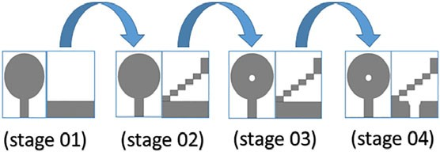

**Fig 2:** Evolution of the proposed antenna in four

steps

Due to the circular slots in the ground plane, it starts resonating in lower order frequency till 3.1 GHz. By adding a circular ring in the patch higher order frequency is achieved till 10.8 GHz. Overall impedance bandwidth of this antenna is 3.1-10.8 GHz. The obtained peak gain is 5.1 dB and peak radiation efficiency is 69%.

III. PROPOSED METHOD

A new compact planar monopole antenna with a simple structure is presented. Planar monopole antennas have all the advantages of the monopole antennas in terms of their cost, and ease of fabrication besides, yielding very large bandwidths. For many applications large bandwidth is required. Recently, many techniques to tailor and optimize the impedance bandwidth of these antennas have been investigated. These include the use of bevels, slots and shorting posts. These antennas are becoming popular, and have been proposed for modern and future wideband wireless applications. The radiation performance is also shown to be acceptable over a wide range of frequency.

The design includes substrate on which the antenna structure is etched and is fed by a microstrip line and involves a design of conventional circular patch antenna with two semicircular slots and rectangular element at back side of the structure, making the antenna to operate in dual band. The presence of a slot in the ground plane assure a broad impedance bandwidth. The simulated results of the proposed antenna indicates the high impedance bandwidth.

The design of the antenna is erected on the cost effective FR4 epoxy dielectric material with the dimensions of 20mm*25mm*1.6mm with the dielectric constant of 4.4 and dielectric loss tangent of 0.025. The monopole is etched on the top side of the substrate, while the ground plane is situated on the back side of the same substrate and is printed on XY-plane which is fed by a microstrip line with a lumped port of 50 Ω of transmission line.

The width of the entire antenna is represented by ‘a’ and length by ‘b’. The presented antenna structure design and parametric values (reported in milli-meter) are shown in below figure. The depth of the (FR4) substrate on which the antenna is etched is designated by ‘h’. structure is being fed by a microstrip line of length ‘d’ and width ‘e’. The design of the patch is simple conventional circular patch antenna with the diameter of ‘c’. Two semicircular slots with diameter of ‘g’ and ‘i’ and finite rectangular element with length ‘f’ and width ‘a’, which makes a ground plane partial.

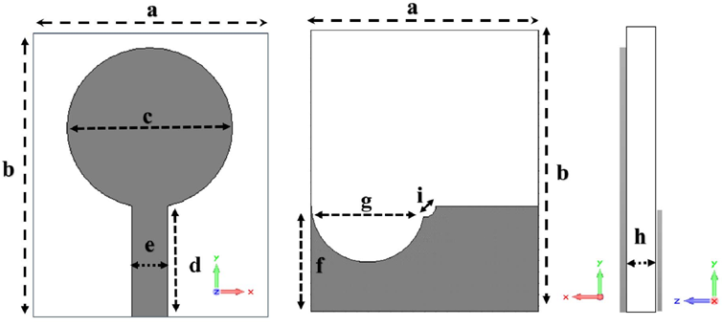

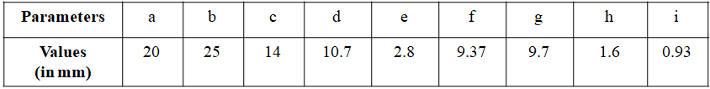

**Fig 3:** Front, back and side view of the proposed antenna with the labelled parameters

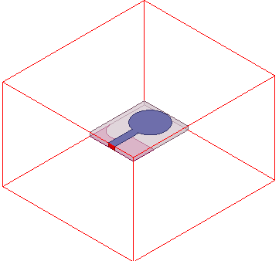

**Fig 4**: Design of proposed antenna

IV. RESULTS

EXISTING METHOD RESULTS

(Corrugated Ladder Ground Plane Antenna)

To achieve the UWB characteristic and WLAN applications, the proposed antenna should cover 3.1 to 10.8 GHz frequency range. Thus, a circular and rectangular slot with appropriate dimensions is introduced in the lower side of the corrugated ground plane, as a result, the proposed antenna starts resonating at 3.1 GHz as shown in

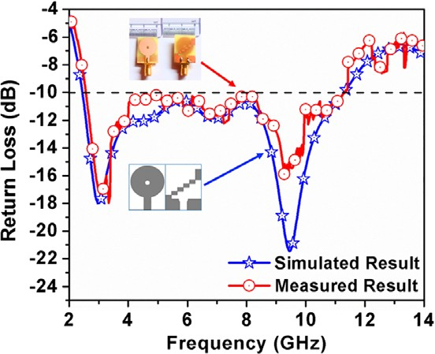

**Fig 5**: The Simulated return losses of the Existing Antenna

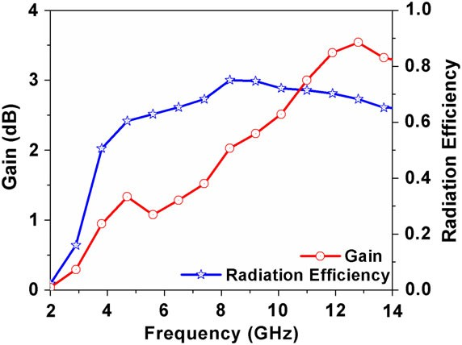

**Fig 6**: Simulated gain and radiation efficiency of the

existing antenna

PROPOSED METHOD RESULTS

(Compact Planar Patch Antenna)

A parametric study is conducted to get the optimized dimensions of the antenna, as proposed. It is worth noting that when one parameter is studied, the others are kept constant. The below plot shows the antenna performance before implementation of semicircular slots for frequency Vs S-parameters in dB. This provides a comparative analysis of the measured and simulated values of the S11 curve (S11< -10 dB) for the antenna structure being presented. It is seen that the results obtained after testing the antenna in the anechoic chamber are in great accordance with the result produced through simulations, which approves the reproduction procedure of the High Frequency Structure Simulator (HFSS).

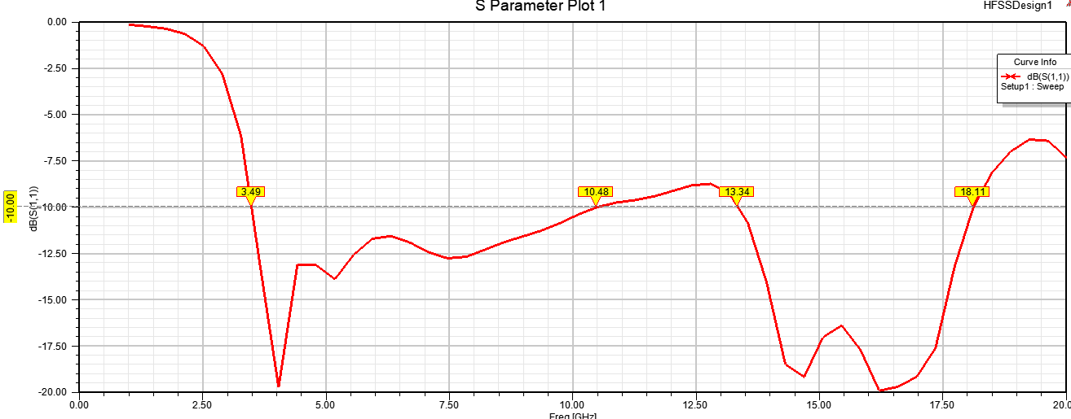

**Fig 7**: S-Parameter Plot without slots in the ground plane

The antenna performance after implementation of slots i.e. frequency Vs S-parameter in dB.

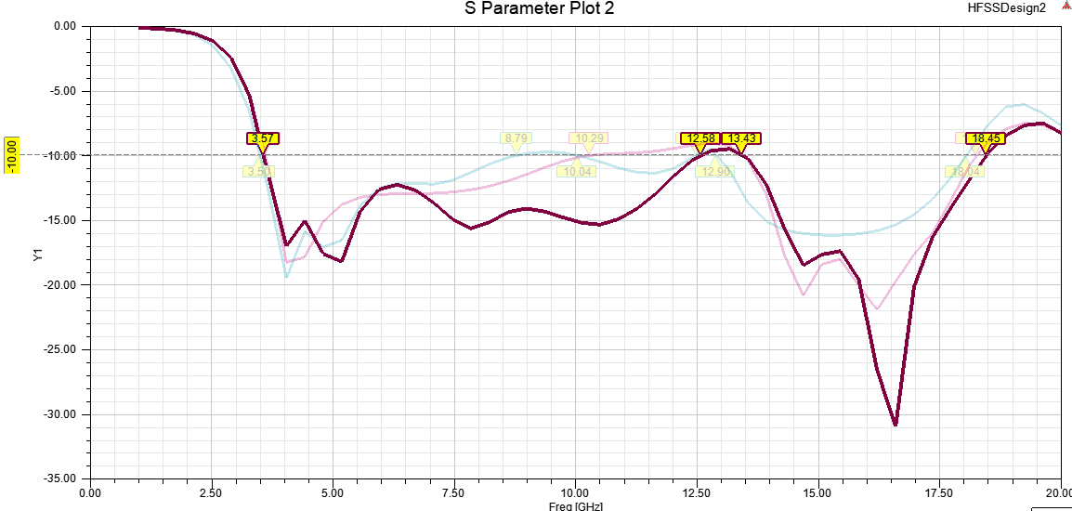

**Fig 8**: S-Parameter Plot with slots in the ground

plane

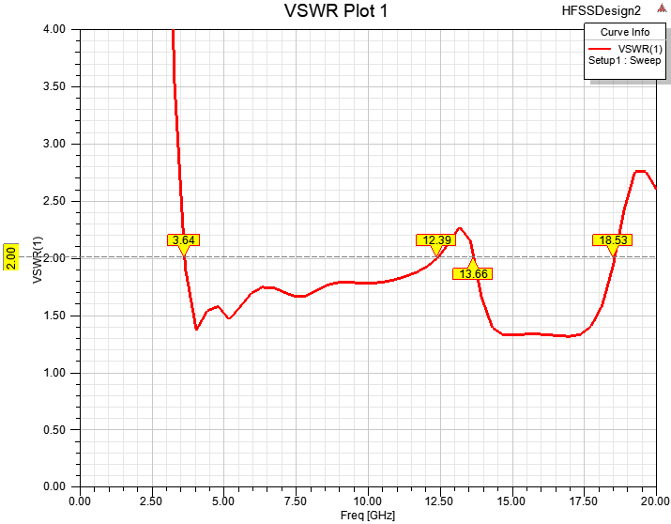

**Fig 9**: VSWR Plot

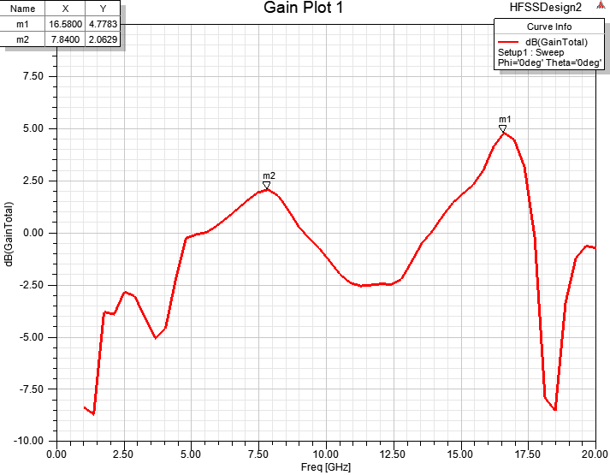

**Fig 10**: Gain Plot in 2D

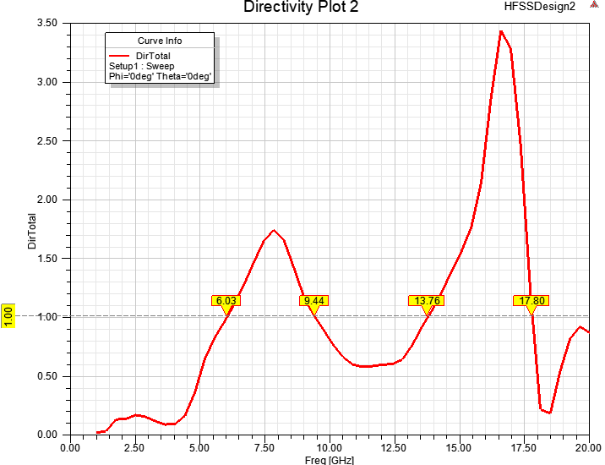

**Fig 11**: Directivity Plot

**Table 1**: Comparison of existing method and

proposed method

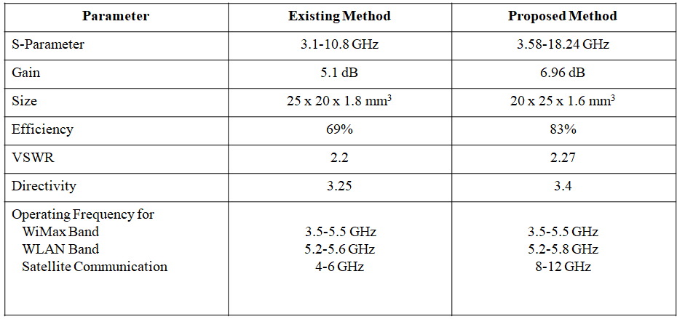

VI. CONCLUSION

The requirement of wireless communication applications in modern days requires higher data rates and higher capacity. The requirements of higher data rates have further promoted need of antennas with multi bands and broad bands. A design of a compact planar monopole antenna for wireless communication is presented. The overall dimensions of the proposed antenna are 20 mm*25 mm*1.6 mm. The substrate used is FR-4 (flame retardant) having a loss tangent of 0.025 with a dielectric constant of 4.4. The fractional bandwidth (S11) of 3.5 to 18.2 GHz. The peak gain and antenna efficiency are 6.1dB and 83% respectively, both of which are achieved in the operational frequency range of the antenna. The proposed antenna covers the complete frequency range of UWB applications, which includes WiMax band at 3.5/5.5GHz, WLAN band at 5.2/5.8GHz, X-band of 8-12GHz, mainly used in satellite and wireless communication.

REFERENCES

[1] M.V. Yadav et al., “A novel design of a planar antenna with modified patch and defective ground plane for ultra-wideband applications,” Microwave and Optical Technology Letters, vol. 61, pp. 1320-1327, 2019.

[2] C. Arumugam and D.W. shaik,“Novel wideband slot antenna having notch-band function for 2.4 GHz WLAN and UWB applications”, International Journal of Microwave and Wireless Technologies, vol. 3, pp. 451-458, 2011.

[3] G. Li, H. Zhai, et al., “A compact antenna with broad bandwidth and quad-sense circular polarization”, IEEE Antennas Wireless Propagation, vol. 11, pp. 791-794, 2012.

[4] H. K. Gupta, P.K. Singhal, P.K. Sharma, V.K. Jadon, “Slotted circular microstrip patch antenna designs for the multiband application in wireless communication”, International Journal of Engineering &Technology, vol. 3, pp. 158-167, 2012.

[5] A. Khidre, K.F. Lee, A.Z. Elsherbeni, F. Yang, “Wide band dual beam U-slot microstrip antenna”, IEEE Trans Antennas Propagation, vol. 61, pp. 1415-1418, 2013.

[6] A. Kurniawan, S. Mukhlishin, “Wideband Antenna Design and Fabrication for Modern Wireless Communications Systems”, ScienceDirect, Procedia Technology, vol. 11, pp. 348-353, 2013.

[7] T.M. Telsang, A. B. Kakade, “Ultra-wideband slotted semi-circular patch antenna”, Microwave and Optical Technology Letter, vol. 56, pp. 362-369, 2014.

[8] S. Baudha, D. K. Vishwakarma, “Miniaturized dual broadband printed slot antenna with parasitic slot and patch”, Microwave and Optical Technology Letters, vol. 56, pp. 2260-2265, 2014.

[9] R. Azim, M.T. Islam, N. Misran, “Printed Circular Ring Antenna for UWB Application”, IEEE, 6th International Conference on Electrical and Computer Engineering (ICECE), pp. 361-363, 2010.

[10] S. Hota et al., “A Compact, Ultra wide Band Planar Antenna With the Patch and A Defective Ground Plane for Multiple Applications”, Microwave Opt Technol Lett. pp. 1-10, 2019.